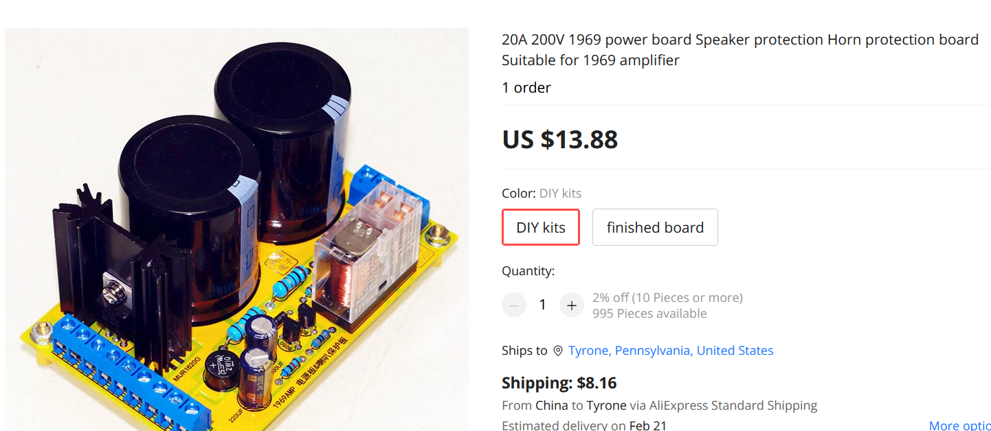**The product does not include 2pcs main capacitor .**

**specification:**

**FR4 65X100X1.6MM yellow board double-sided design.**

**The main parts specifications:**

**Rectifier: Select imported original Schottky TSV20100CG (20A 100V) or imported original Schottky MBR20200CTG (20A 200V)**

**Relay: imported original 24v Japanese Omron relay.**

**Electrical performance: AC three-wire input, single DC output, DC voltage is about 1.3 times of AC voltage, suitable for AC dual 18V transformers.**

**Power-on protection: power-on delay and charging of 1969 capacitor, eliminating impact sound at power-on**

**Shutdown protection: Shut down instantaneously.**

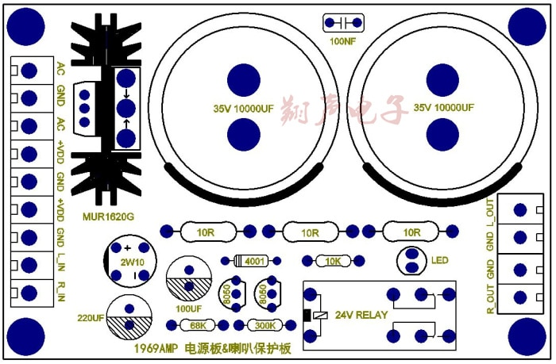**1969 power board uses a unidirectional full-wave rectifier circuit (half the bridge rectifier internal resistance), and the filter capacitor is suitable for a 10MM maximum diameter 35MM capacitor. It is the first power board of single power amplifier.**