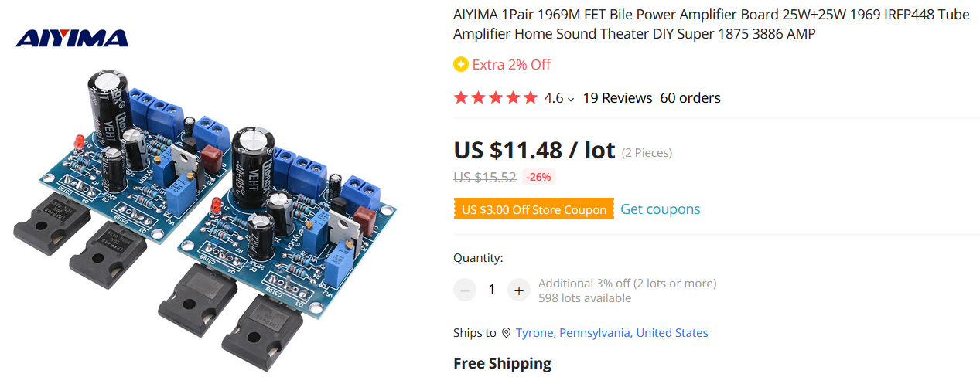Product Name: 1969M FET bile power amplifier board

**IRFP448 large tube (disassemble)**

  Model: 1969M

  Supply voltage: single DC12-35V

  Output power: 1-25W

  Power tube model: disassemble IRFP448 large field effect tube

Large tube IRFP448 large tube version DC12V-35V power supply. Current 30-60MA adjustable, small current sound is very good, the current needs to increase the heat sink, please pay attention! !

  Method of adjusting current:

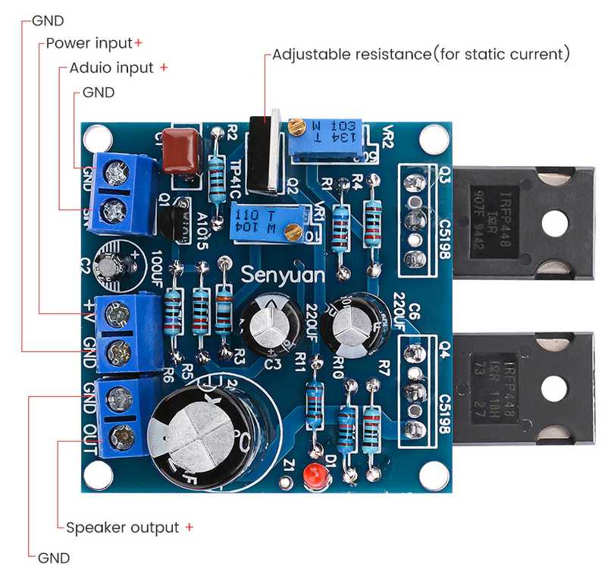  Adjust the "502 adjustable resistance" clockwise to adjust the static to between 10-60MA