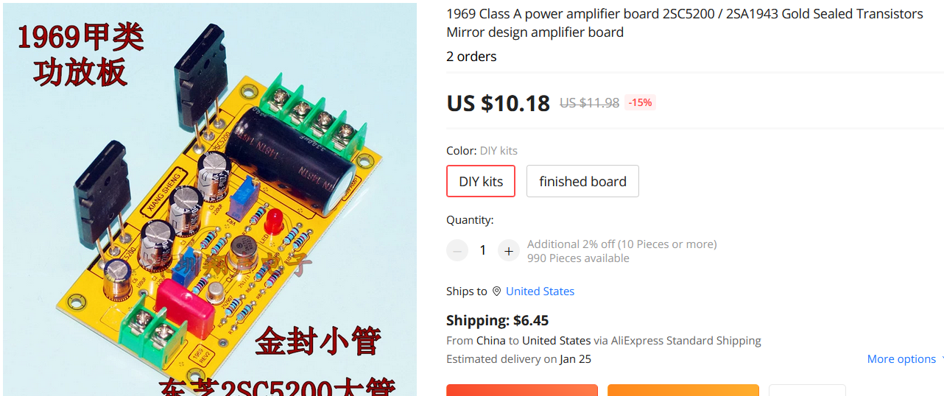

**Note that this is a mono, 2.0 channels need to buy 2PCS .**

**Gold Sealed Transistor, 15A 150W 2SC5200 Audio Pair tube .**

**Supply voltage: It is recommended to use a single 18V----26V DC power supply, quiescent current 500MA ---- 1A**

**debugging:**

**The 2K resistor is a quiescent current. Please control the temperature according to the size of the heat sink. 100K midpoint voltage (adjusted to half the supply voltage), T1 test point, is the output capacitor positive .**

