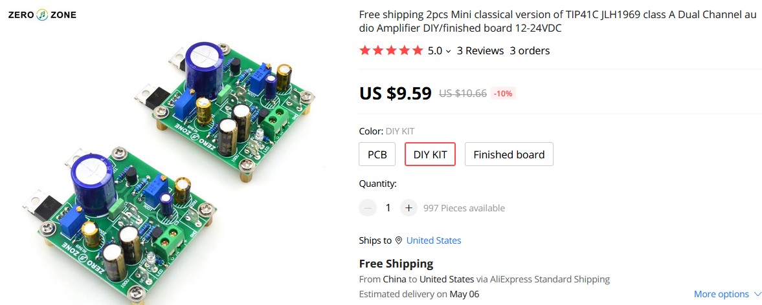The version is using a mono board structure, small PCB can adapt to different types of chassis and heat sink, install more freedom

PCB Size: 50 \* 50 \* 1.6MM, 1OZ copper spray tin process, with a push tin belt.

Recommended input voltage: 12-24VDC

Applicable to recommended amp and small desktop power amplifier

This finished board is commissioned at 18VDC, 1A quiescent current