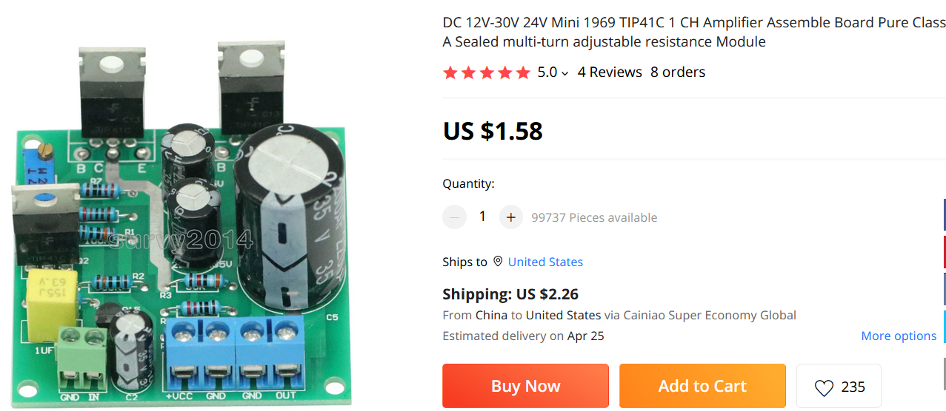

Technical specifications:

1. Model: 1969 small group A

2. Tube Model: TIP41C

3. Output power: 5 W per channel

4. Power consumption: 20 W

5. Power source: DC 12-30V

6. Current Static: Standard 25 v DC to 0.8-0.9A

7. Board Sizez: 5x5cm

8. Resistance: Fully five-precision metallic film resistor ring

9. Adjust Resistance: Sealed multi-turn adjustable resistance

10. Input Capability: Farah Campaigns Promise

11. Electorlytic capacitor: high capacity